Please carefully read the entire production process and then do it better!

First talk about the issues that need attention before soldering

1. The soldering temperature should not be too high below 320°C

2. We recommend that the soldering iron be grounded and that it is best to wear an electrostatic wrist strap grounding solder. The soldering speed should be as fast as possible.

This kit is very simple to weld, let's get started

First solder the components on the back of the PCB. Note that all soldered components must be soldered before soldering. The following are the soldering positions of the components.

R1--R2(1M(105)), R3--R7(10K(103)), R8(2K(202)), C2, C4, C5(100nf(104), Q1(9012(2T1)),

U1 (44-pin microcomputer), U2 (AMS1117), U3 (DS3231 clock chip), LED1-LED2 (ice blue LED)

Mic (Microphone)

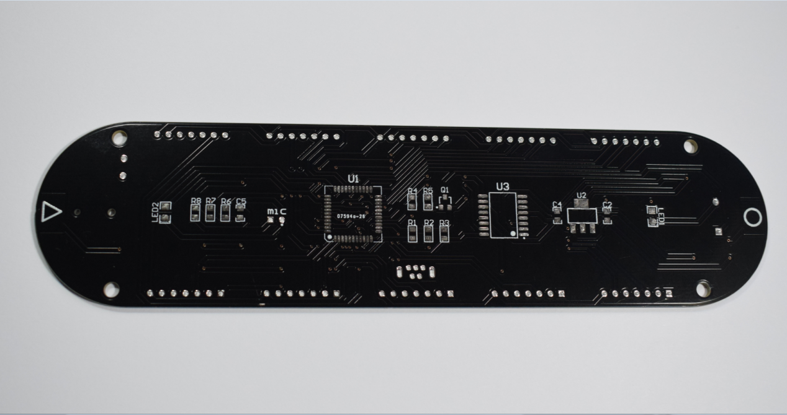

First solder three SMD ICs, please note the U1 and U3 soldering direction, do not solder reverse, soldering as shown below

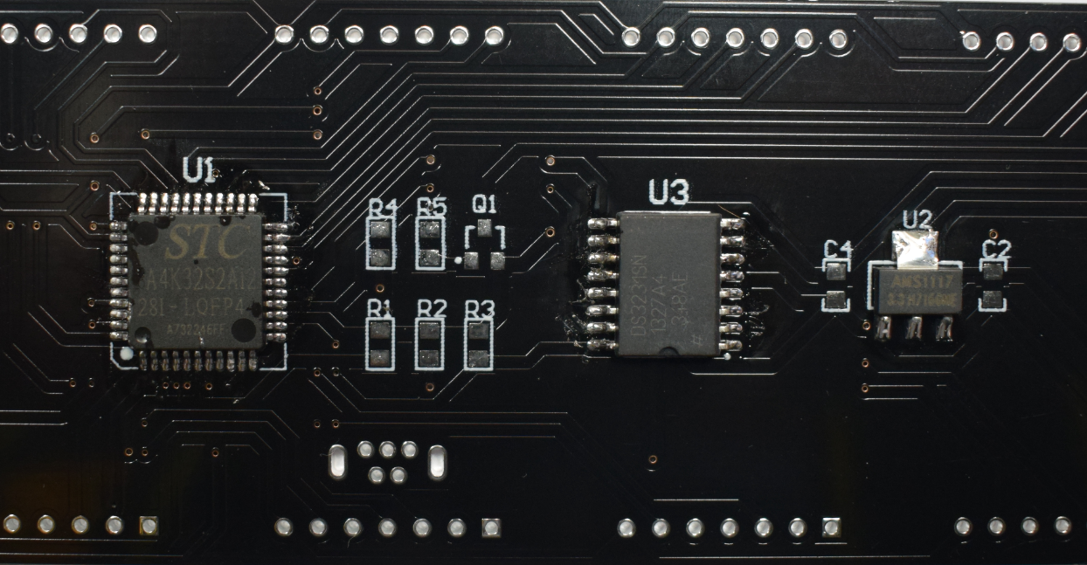

Solder blue LED, pay attention to the LED cathode is the end of the green point, corresponding to the LED package octagonal that pad, as shown below

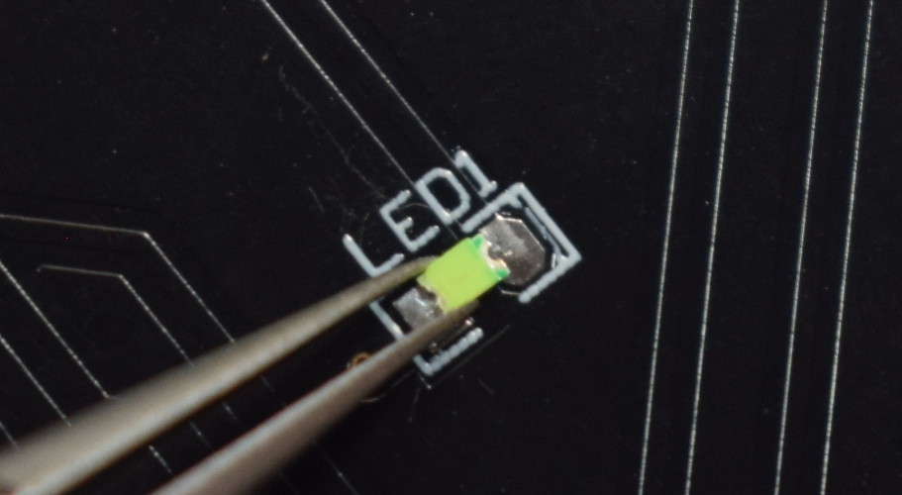

Then soldering resistors, capacitors and transistors

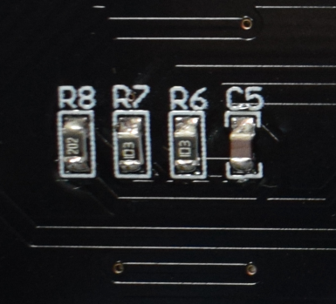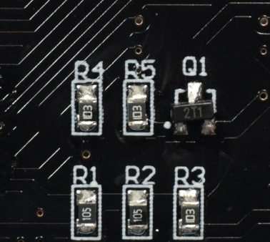

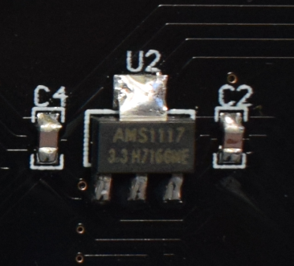

Next to the soldering microphone, there is a negative electrode on the back of the microphone with three leads connected to it, and the negative electrode corresponds to the pad on the white point, as shown in the figure below.

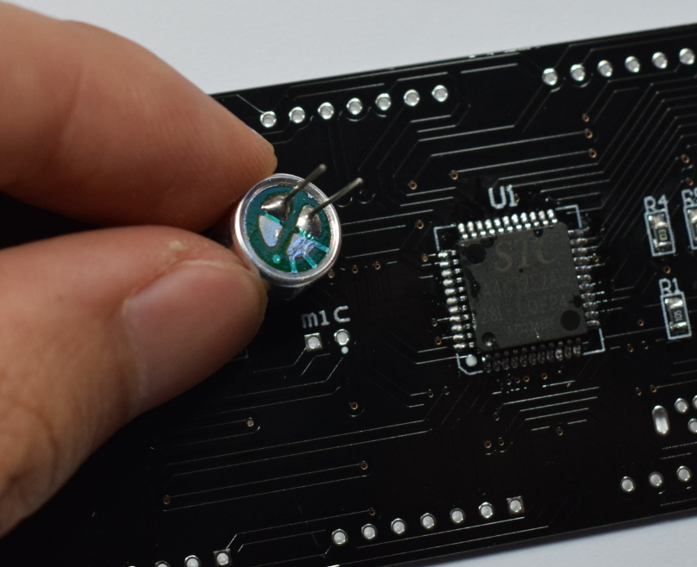

Soldering mini USB socket, as shown below

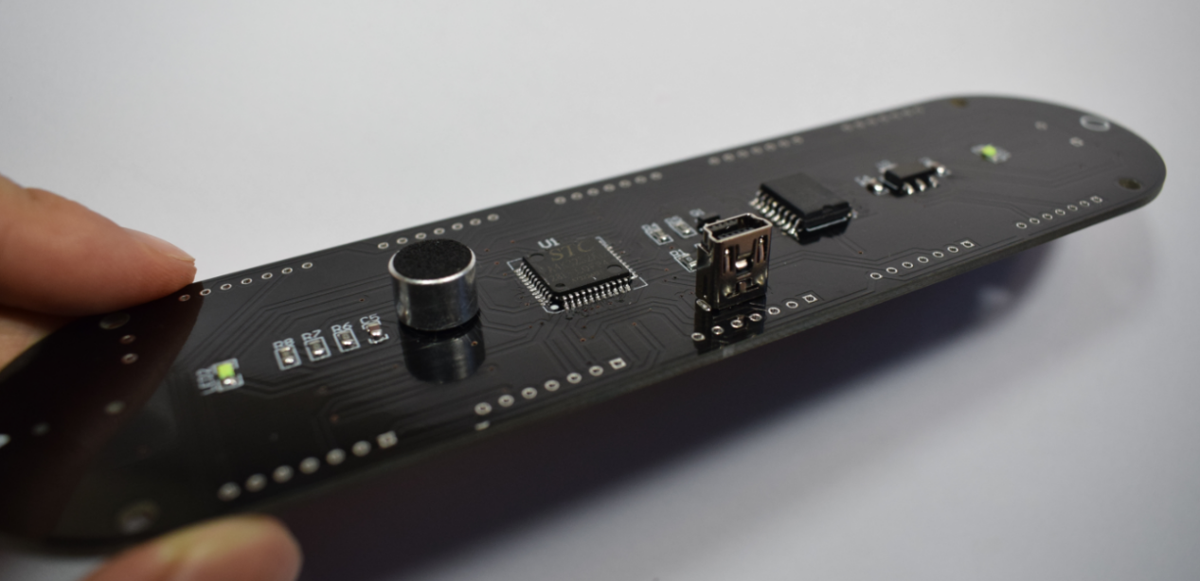

After all the devices on the back are soldered, we can flip to the front to solder other devices, first solder buzzer, 220uf capacitor and 10uf capacitor, please be careful not to solder back, after soldering as shown below

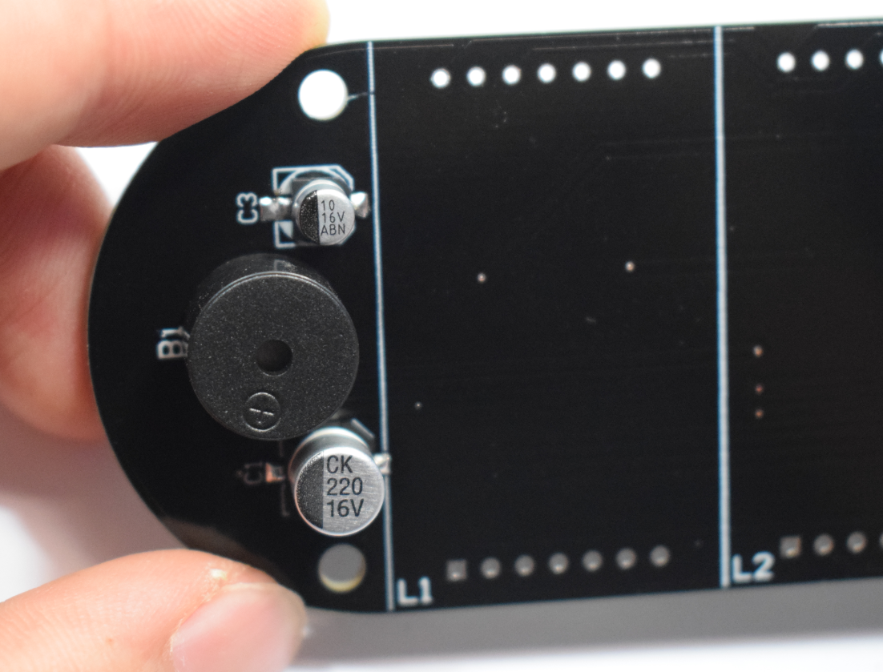

Soldering CR1220 battery holder and photoresistor, please note that the photoresistor should be placed as shown below

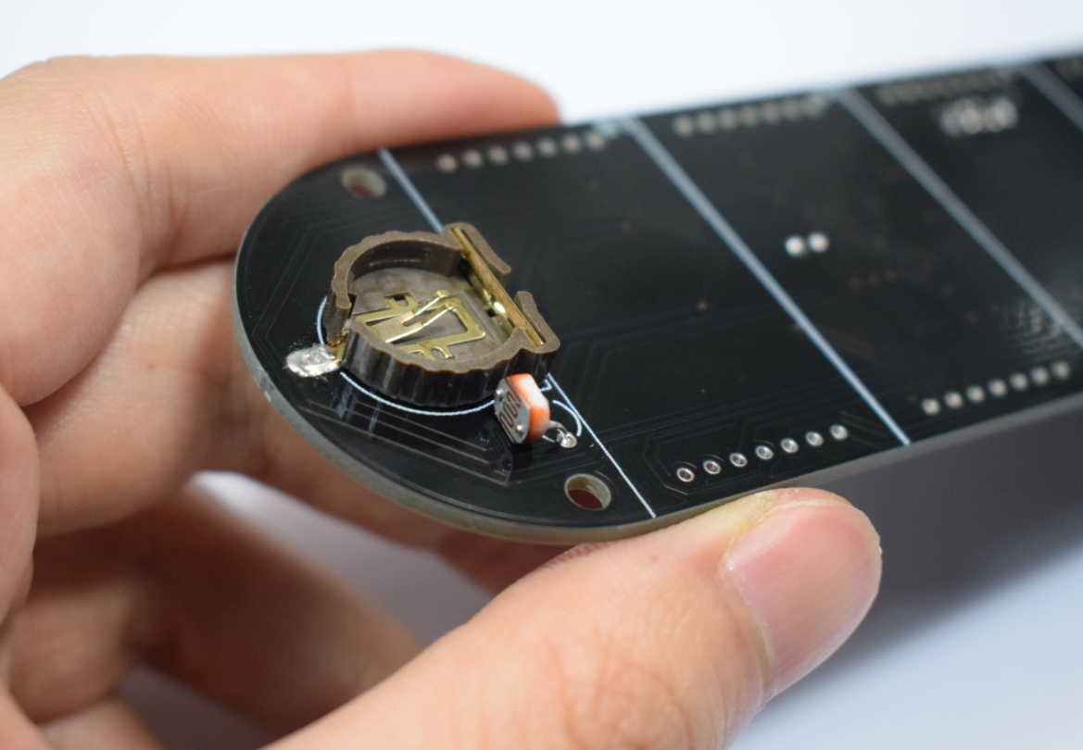

After soldering all the small components, we will not solder the LED dot matrix at this time. At this time, first plug in the circuit board to test the function. After the power is on, the LED will flash. The buzzer will scream, indicating the initialization is normal, and then touch the touch. Press the key to see if the buzzer will sound, if the LED flashes when touched, if the buzzer is not called, please check whether the mini USB socket or the MCU and DS3231 soldering are short circuited and whether soldering is correct. Touch buttons do not respond, please check whether R1 and R2 are soldered. If the buzzer is not called, please check whether DS3231 and 9012 Triodes are soldered.

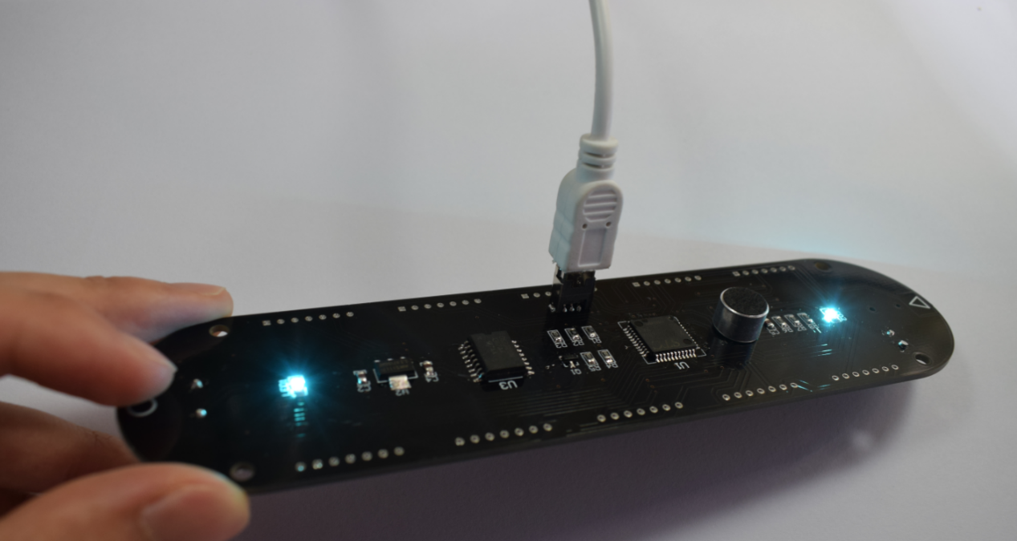

After the function check of the circuit board is completed, we finally weld the dot matrix module, and the side of the dot matrix module has the word corresponding to the end of the circuit board package labeled L1-L5.

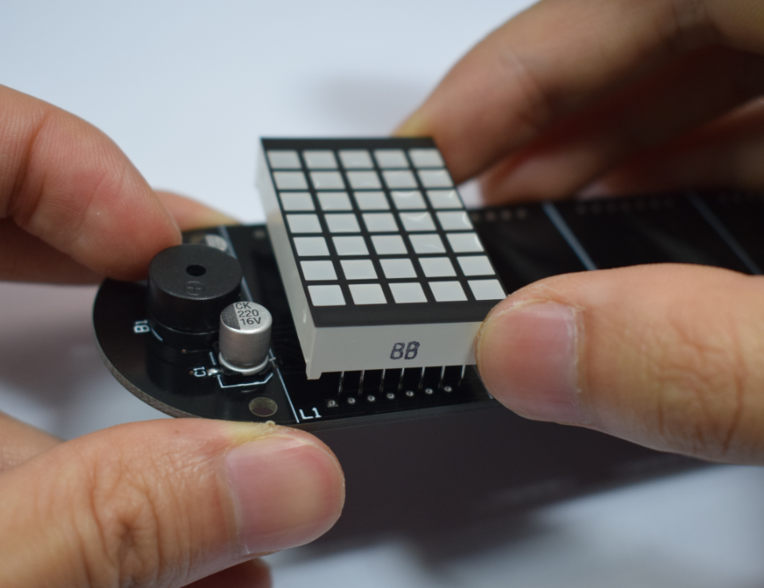

Please note that the dot matrix module must be soldered as closely as possible

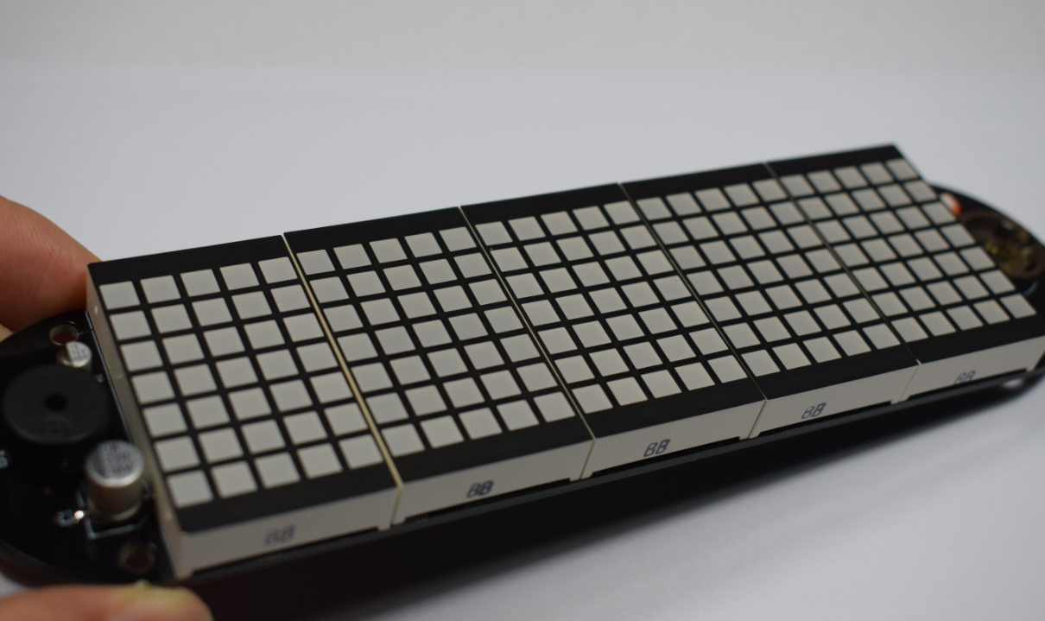

Cut off the extra pins behind

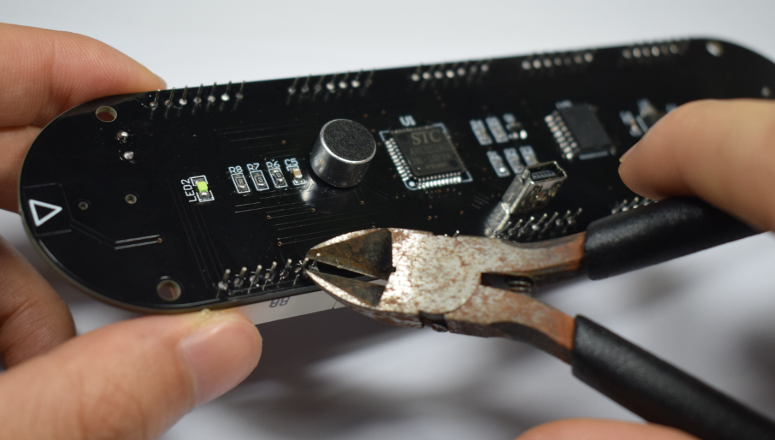

Install acrylic panel

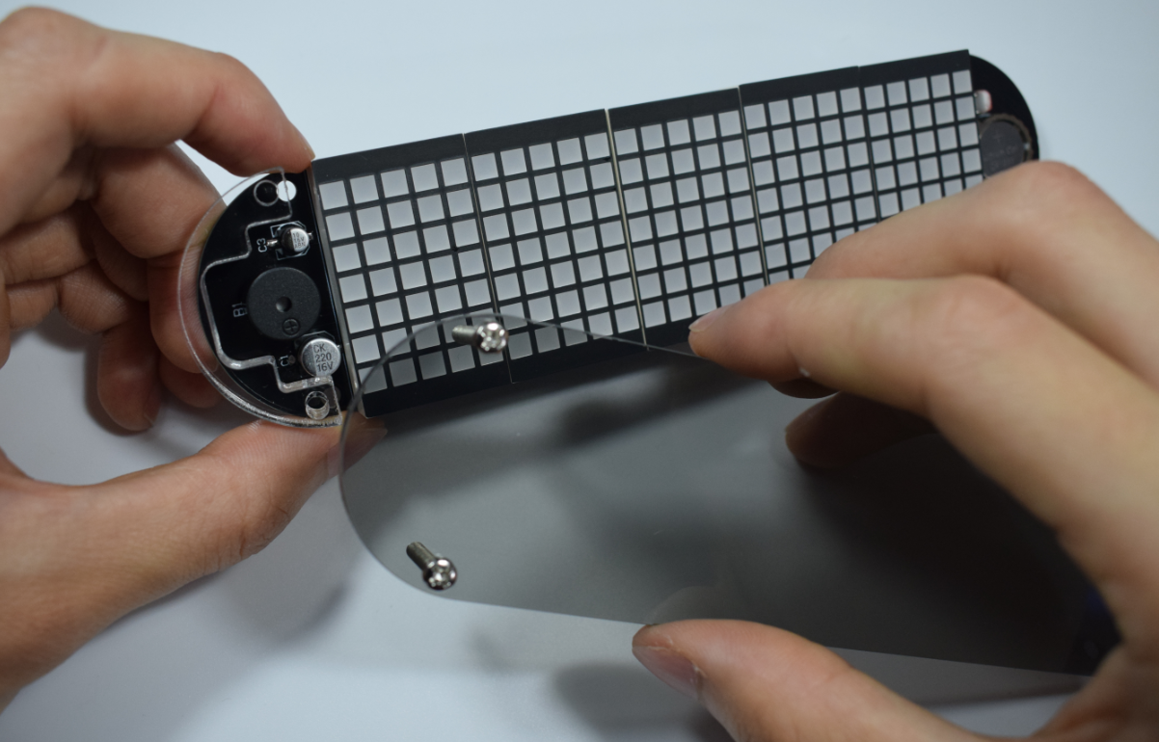

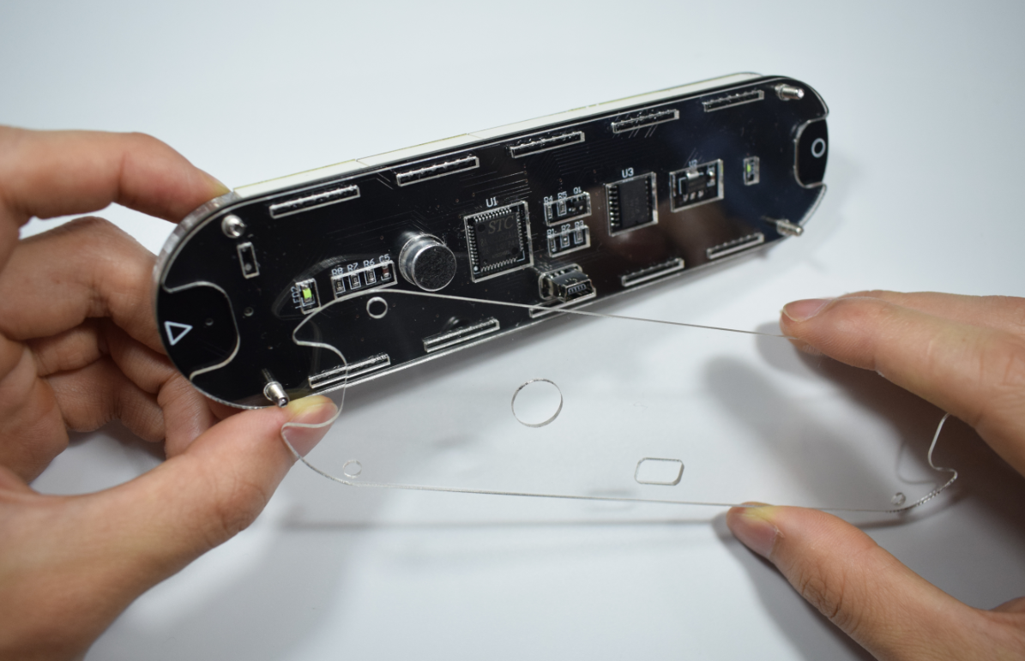

Plug in the USB cable,cool!

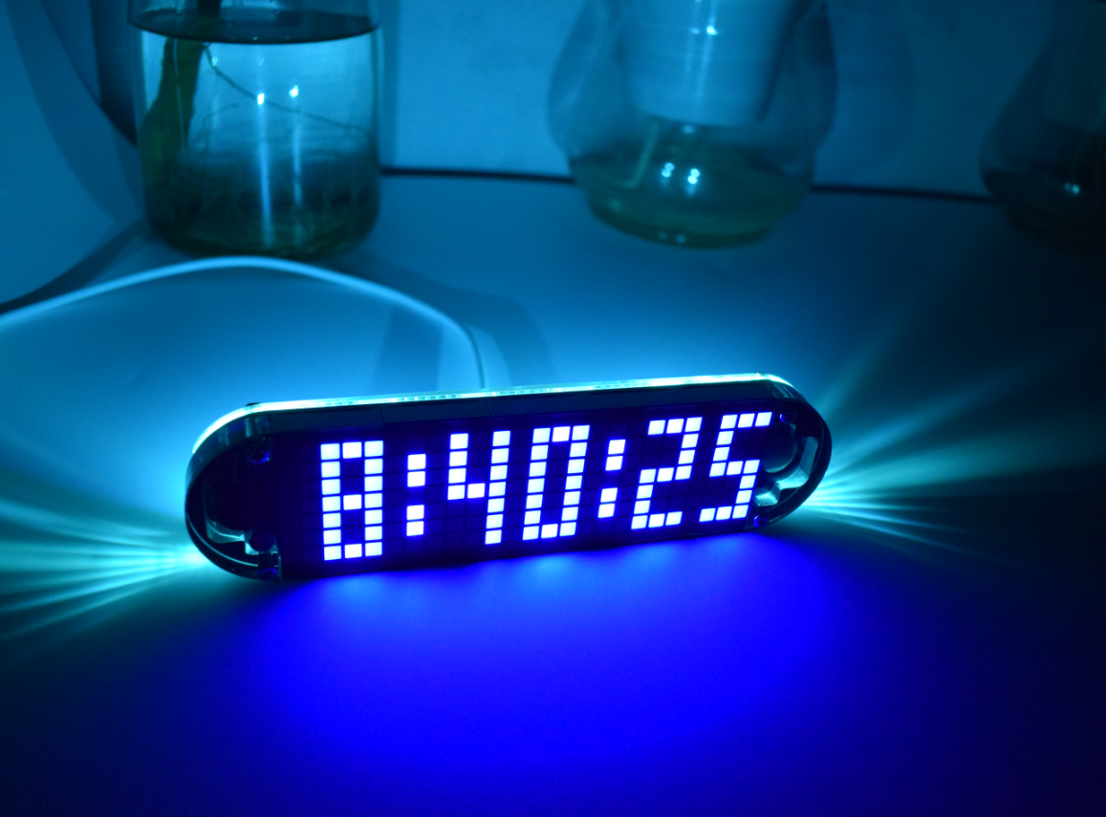

Features:

1. Simultaneously press the setting (circle symbol) + switch touch key (triangle symbol) to enter or exit the menu;

2. Short-touch switch key (triangle symbol) to switch time setting(Time) - Date setting(Date) - Alarm setting(Alarm) - Font style setting(Font) - Switch animation effect setting(Display) - Midpoint bounce effect setting(Midpoint) - Format setting(Format) - Birthday mode setting(Birthday) - Brightness setting(Brightness) - Time display mode setting(Show) - information switching time settings(Speed) - Time digital change effects settings(Move) - Voice switch settings(Sound) - Backlight LED effects settings(Back-Led) - Countdown settings(Count). Short press the setup key (circle symbol) to enter the setting, and then change the parameter value by the switch key (triangle symbol).

parameter settings:

1. Time: switch key (triangle symbol key) to modify the flashing parameter value, set the key key (circle symbol key) to confirm the modification;

2. Date: The modification order is: year-month-day;

3. Alarm clock: ON - Turn on the alarm clock and enter the alarm time setting; OFF - Turn off the alarm clock

4. Font: font style 1-5;

5. Switching mode(Display): 0-only display time; 1-scrolling switch to the left; 2- random lighting switch; 3-drop switching one by one; 4-light up and down light switching; 5-middle separation switching; 6-way middle Rollover; 7-up and down rollover; 8-side sweep switch; 9-direct light switch;

6. Colon beat effect settings(Midpoint): 1 - middle confluence beats; 2 - fade up and down; 3 - constant light; 4 - move up and down; 5 - light up every second

7. Format settings(Format): Hour (hour format): 24h-24 hour mode; 12h-12 hour mode. Date (date format): MM-DD: month-day mode; DD-MM: day-month mode. Temp (temperature format): C-Celsius; F-Fahrenheit;

8.Birthday reminder settings(Birthday): ON-open reminder function and enter the parameter settings; OFF-close reminder

9.Brightness level settings(Brightness): level: 1-5 brightness; A-automatically adjust the brightness according to the environment;

10. Time display mode(Show): HH:MM-Hour:Minute mode; H:M:S-Hour:Minute:Second mode; H: M ss-Hour:Minute second mode; A H: M-a/p Hour: Minute mode (12 hours);

11.Information switching speed settings(Speed): 5s-5 seconds to switch information; 10s-10 seconds to switch information; 30s-30 seconds to switch information; 60s-60 seconds to switch information; 120s-120 seconds to switch information;

12. Special effect of time digital change(Move) (Only for switching mode 0): 0-Direct change; 1-Extend one by one; 2-Drop mode; 3-Random light up; 4-Up and down; 5-Middle out

13.Voice control settings(Sound): ON - open voice control mode; OFF - turn off the voice control mode

14.Backlight effect settings(Back-Led): 0 - off the backlight; 1- constant; 2- follow the sound; 3-breathing mode;

15.Countdown setting(Count): Enter the minutes and seconds, press the set button (circle) to start the countdown, countdown buzzer to end, any touch key to exit the countdown;

Special reminder: time digital change effects only on Switching mode(Display): 0-only display time;